Note on Correct Thai Pronunciation and Transcription

by Gavesako Bhikkhu (version 1.1 – May 2020)

NB: In this article, bold characters indicate sounds as they are actually pronounced.

At a Sangha gathering, a senior Thai monk introduced a senior American monk who was going to give a talk in Thai to the assembled laypeople, and then added as a joke: “If you can bear the sound of a Phra Farang.” Recently I had a discussion with Ajahn Jayasaro about the way Westerners mispronounce Thai, which is often the result of unclear transcription. For example, Americans tend to pronounce the ‘r’ at the end of Luang Por (หลวงพ่อ). (One of the few things, Ajahn Jayasaro said, that can raise his blood pressure.) Of course, there is no ‘r’ sound in the Thai word for ‘father’ at all, it is just a transcription chosen by a Southern British speaker who would naturally pronounce it as phō (just like in “pour a cup of tea”). If the transcription had taken into account how Americans will tend to pronounce it, it might have been Luang Poh instead.

Another feature of ‘hard’ American pronunciation is how ‘t’ is often pronounced as d. When speaking English, it might not cause any confusion whether you say ‘butter’ with a t or a d sound, but in Thai these would be quite distinct words. So it is important to choose a transcription that will reflect these sounds accurately. To an American the word Luang Ta (หลวง ตา) might sound like Luang Da, but that might just be an American ‘hard’ pronunciation of it. The word ตา (tā grandfather) needs to be distinguished from the wordด่า (dā to curse). Similarly with Luang Pu (หลวงปู่) which an American might spell as Luang Bu. The ‘p’ can thus turn into b. Here, the word ปู่ (pū grandfather) needs to be distinguished from the word บู๊ (bū to fight).

Speaking from my own experience, I was also misled by inaccurate transcriptions of some Thai names and by the way everyone around me was pronouncing them. For example, the name of Ajahn Dtun is usually spelt like this and pronounced as Dan. It took me about ten years before I heard his name from a native Thai speaker who was pronouncing it quite clearly as Tan (ตั๋น). The problem with the Paiboon transcription system is that people don’t know how to pronounce ‘dt’ without breaking their tongue, and so they just pronounce the first consonant, namely ‘d’. The same is true for ‘bp’. One person I knew had already learnt good Thai but could not properly distinguish the sounds b and p. When trying to say the word pai (ไป to go) they would say bai (ใบ leaf) instead, because they learnt it like that from the Paiboon transliteration ‘bpai’. Native Thai speakers corrected them but they could not hear the difference.

Benjawan P. Becker's Thai for Beginners (where people picked up the Paiboon system from), which transliterates ป as ‘bp’ and ต as ‘dt’, gives this explanation: The /dt/ sound lies between the /d/ and the /t/. Similarly, the /bp/ is between /b/ and /p/. This is hard to follow for English-trained ears. The point is that ป /p/, ต /t/, and ก /k/ are unaspirated, but not voiced. There are separate aspirated phonemes พ /pʰ/, ท /tʰ/, and ข /kʰ/. Since ‘p’, ‘t’ and ‘k’ in initial position in English are always aspirated, the unaspirated Thai sounds are difficult to hear and pronounce for native English speakers. They are then mostly confused with the voiced บ /b/ and ด /d/.

I remember having a hard time at first trying to figure out how to pronounce “Acharn Maha Boowa” just from looking at the printed name. It was probably Ven. Panyavaddho who came up with this romanization, but for a non-native English speaker it was not easy to convert it into the correct sound. More helpful way to write this name, as used by other translators, is Ajaan Maha Bua. It is quite straightforward to use Bua (บัว) which almost everyone will be able to pronounce correctly, whereas “Boowa” might mislead people to pronounce it as a long “boo” sound followed by “wa”.

Any system of romanization for Thai should be consistent and avoid letters which are ambiguous and could be pronounced differently depending on how one looks at them. One such letter is ‘g’ which is sometimes used for k (ก), but English speakers might instead pronounce it as a ‘j’. There is no hard and fast rule in English how to pronounce words with ‘g’ (e.g. garage), so an unfamiliar word from an Asian language will be hard to guess.

When I first started learning Thai, a Swiss monk gave me a useful piece of advice, which was to avoid a certain standard textbook that the previous generations of monks have mostly used to learn from. The reason was that the author of the book was an Australian, and the system of transcription only made sense to someone speaking the Australian accent; other English speakers pronounced the Thai words wrong based on his transcription. In those days it was difficult to actually hear the sounds of Thai language while living abroad, but nowadays there are websites and apps where one can listen to Thai words being pronounced accurately by a native speaker.

In the context of our European monasteries, it is worth bearing in mind that when we write something it will be read by many people (perhaps even a majority) whose native language is not English. Our communities are so diverse that we cannot assume a common language background. This might be different for example in north America where most community members speak the same general dialect of the same language. As one monk told me: “I am an American and the only language I know is American.” In Europe it is quite common in most countries to be learning at least two foreign languages at school, English being just one of them. So young people will have an understanding of how different languages work in terms of spelling and pronunciation; they will not take their native tongue for granted as the ‘default’ language. That is why the different systems of Thai transcription, or romanization, should not be expected to be transcriptions into English. Various people have come up with their own rather confusing ‘intuitive’ spellings of Thai words using Roman characters, by making them ‘look like’ familiar English words or parts of them. This is certainly not going to be understood by any non-native English speaker who will never expect an obviously foreign word to be written and pronounced as an English word. To pronounce such a word correctly as intended, they would have to perform considerable mental gymnastics by imagining how a native English speaker would likely perceive this combination of characters. So this is a non-starter for most Europeans and it is better to use a system of transcription that conforms as much as possible to international standards, i.e. systems used for other languages.

People associated with our monasteries will have one advantage: they will already be familiar with the system of Pali transliteration as used in the Forest Sangha chanting book and all our publications. Therefore it makes sense to adapt and use the same system for Thai words as well, adding some vowel combinations (ae, eu, ua, ia) that are specific for Thai. Often people don’t know, when reading a text, which unfamiliar new word is Pali and which is Thai. Sometimes Pali and Thai words are mixed together and it is really confusing to try to pronounce them using two different systems.

For example, consider the name ‘Ajahn Mun Bhūridatto’ where the first two words are Thai and the third one is Pali. From my experience, at least half of the people that I meet in our monasteries mispronounce the word ‘Mun’ (มั่น) as Mun rather than Man because they assume it must be transliterated as a Pali word. Not only that, but once they have learnt this incorrect pronunciation, they stick to it for years despite hearing the name correctly pronounced by more senior and knowledgeable people around them. Thus they develop a ‘cognitive bias: systematic pattern of deviation whereby individuals construct their own subjective version of reality leading to perceptual distortion,’ also known as ‘willful ignorance: ignoring any sensory input which appears to contradict one’s inner model of reality’. This is quite a common tendency when learning a new language, wanting it to fit into the categories already familiar from one’s own language, thus leading only to frustration.

Another example would be phansā (พรรษา rainy season) which is sometimes written as ‘punsa’. If I tried to read it without having heard the word before, I would never get it right because I would not expect it to be similar to some hypothetical English word.

One feature of Thai, just as in Pali, is that aspirated consonants (with a puff of air) need to be distinguished from unaspirated ones (without a puff of air). Unaspirated consonants exist in English too: compare the sound of ‘p’ in ‘pot’ (aspirated) and ‘spot’ (unaspirated). In Pali the distinction is represented by writing aspirated consonants followed by ‘h’ and unaspirated ones without it (e.g. attha/atta). There are many similar words in Thai which can be mixed up if this is forgotten. The sounds of ‘ka’ and ‘kha’, ‘pa’ and ‘pha’, ‘ta’ and ‘tha’ need to be kept separate.

Some English speakers don’t realize that only words with Greek/Latin roots which contain the letters ‘ph’ are pronounced with an f sound. They might assume that it is a feature of all foreign languages, but it is clearly wrong to expect that from an Asian language. And similar with ‘th’, which hopefully most people will pronounce correctly in ‘Thailand’. Many words start with ‘pra’ (ประ), but this is a different sound from ‘phra’ (พระ), and the meaning will be correspondingly different as well. For example, prathet (ประเทศ country) is not the same as phrathet (พระเทศน์ monk teaching).

The regular alms-giving ceremony during which a cloth used to be hung from a tree in the forest is known as ‘Pha Pa’ (phā pā). The first word means ‘cloth’ and the second word means ‘forest’ (as in ‘Wat Pa’).

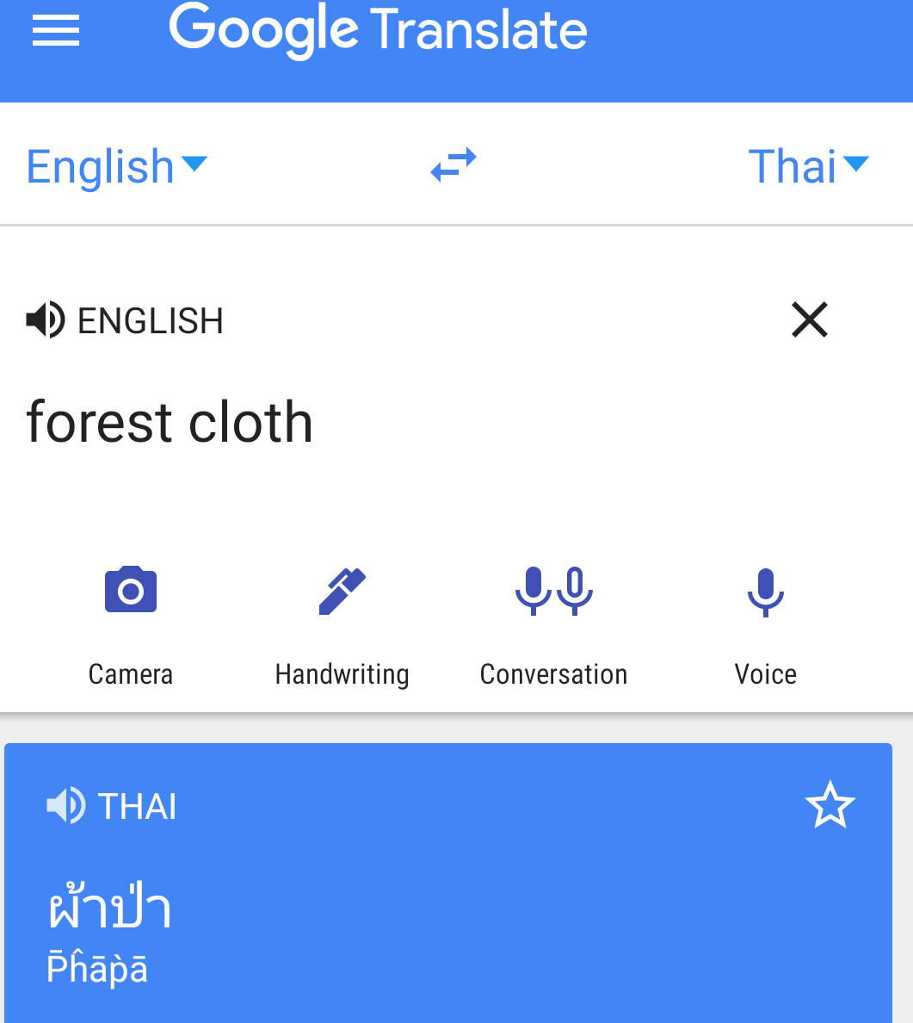

One should be careful how one pronounces these words, otherwise one might end up saying something else than intended:

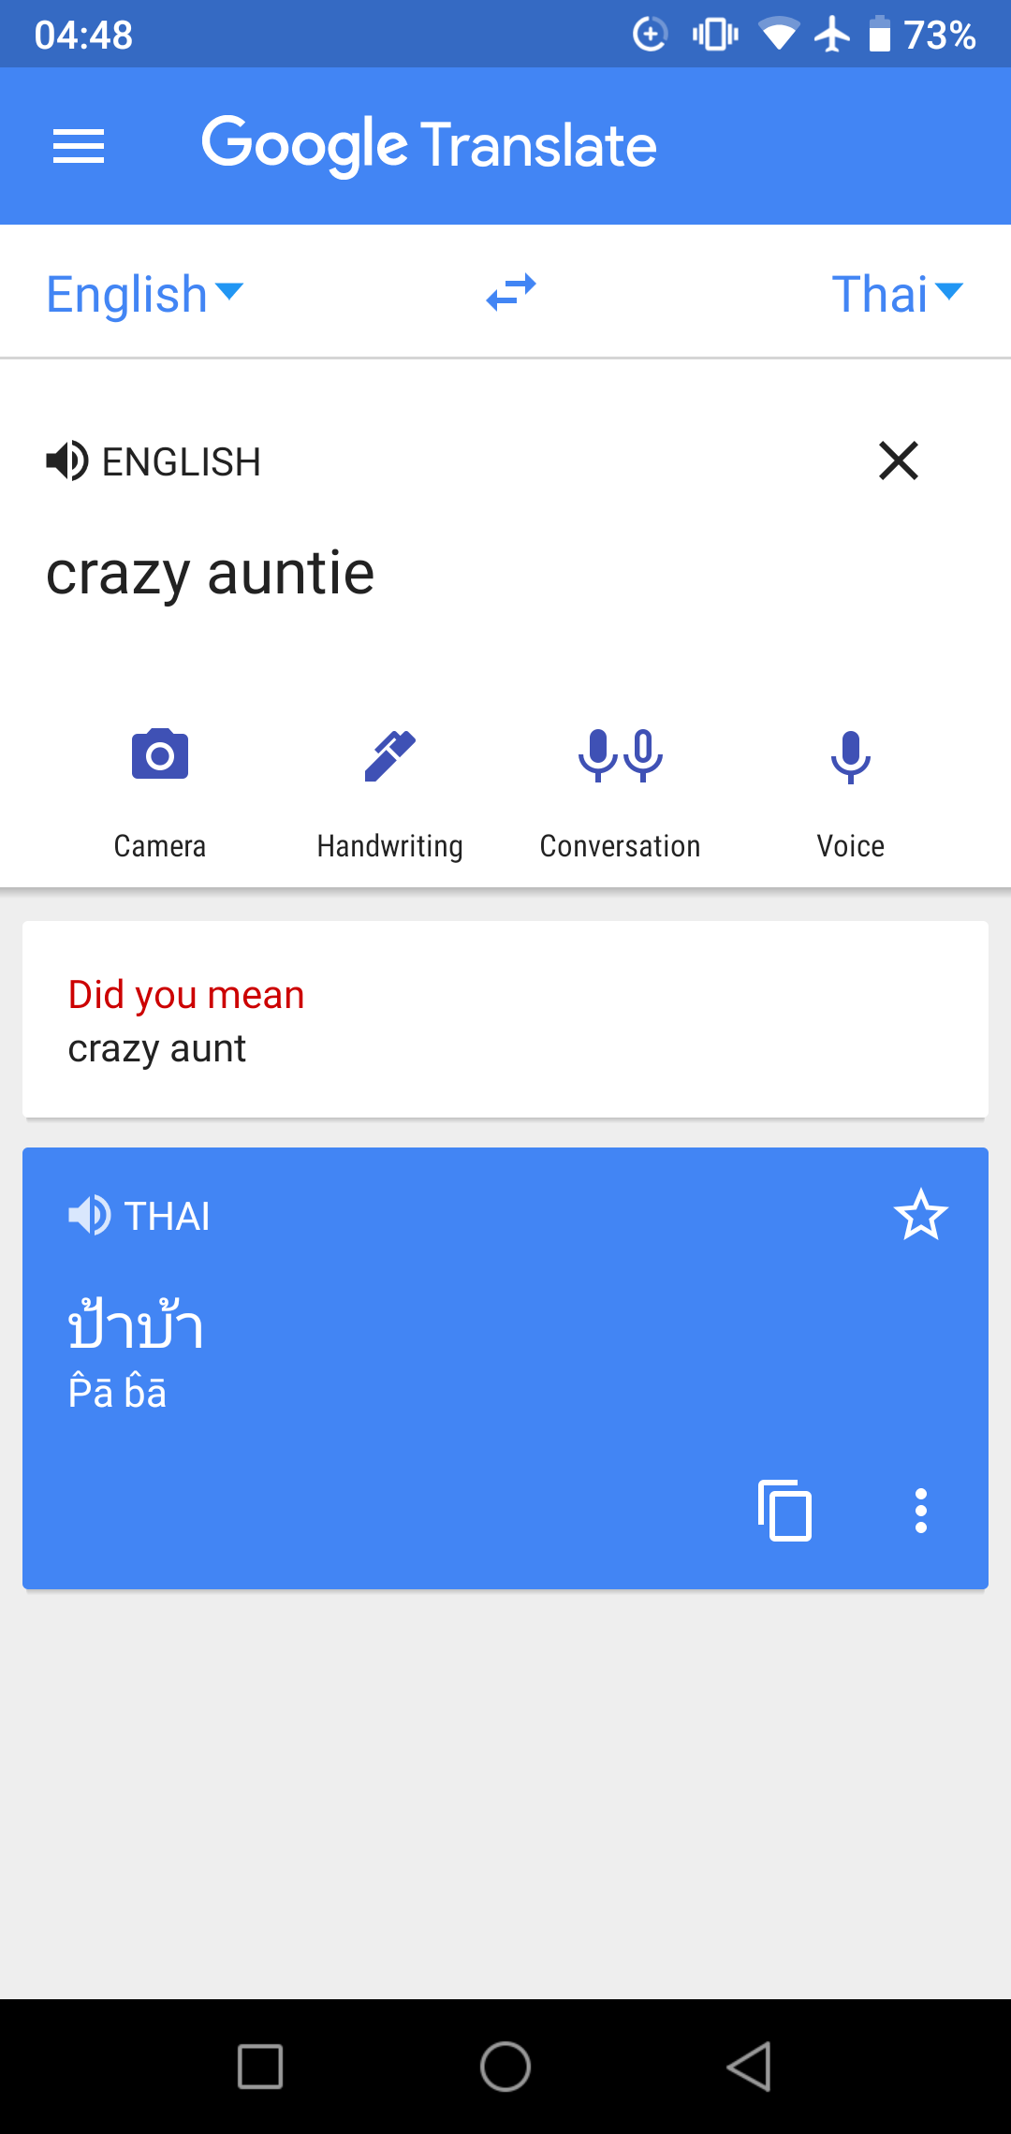

Perhaps an elderly lay supporter might think you are referring to her!

Or with a different tone it might sound like this:

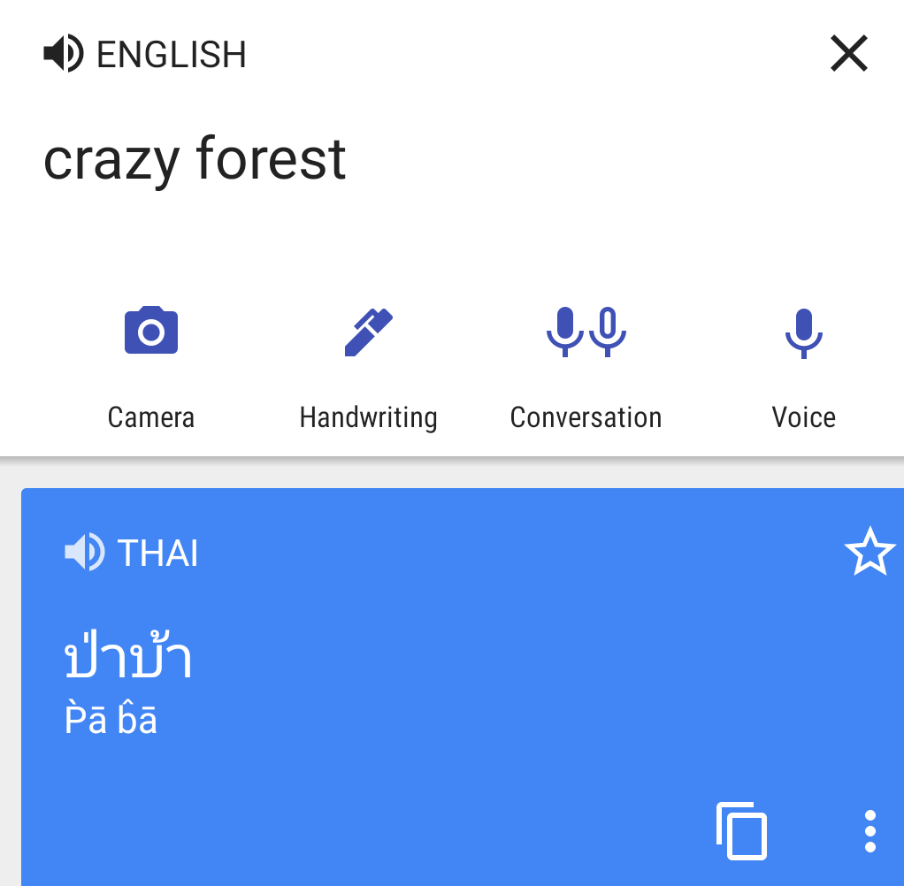

There are about ten systems of transcription which have been developed by linguists in the last century to represent the sounds of Thai language using Roman characters. They can be compared here:
https://en.wikipedia.org/wiki/Romanization_of_Thai
http://www.thai-language.com/ref/phonemic-transcription
https://slice-of-thai.com/pronunciation-guides/

What follows are some relevant quotes that should provide more detail and examples on this theme.

* * *

Different cultures that use the Roman alphabet assign different values to the letters of that alphabet. Countries with non-Roman alphabets don't necessarily want to have a whole series of different Roman transcriptions, to suit the tastes of different users of the Roman alphabet. Any reasonably regular transcription system is as good as any other; all possible transcription system will give some foreigners better clues to pronunciation than other foreigners. Just pick one and stick with it, unless you find a very compelling reason for changing it.
Whatever system one uses will have trade-offs. If you transliterate to make it easy for Americans to pronounce some words roughly correctly, you'll end up with some words that can not be rendered at all, and some words that will be mispronounced by non-English foreigners who are more familiar with 'u' being the English 'oo' sound, 'i' being English 'ee', 'ai' being English 'ie' (as in 'tie'), etc.
There is a conflict between transliterations to a 'generic' Roman alphabet, and to English specifically. But a single transliteration is needed!
Thais do not get different passports depending on which country they're traveling to. Nor do Bangkok street signs show separate renderings for English, French and German. A Thai who travels abroad will have one passport with his/her name written with Roman letters. Should he instead have separate passports for travel to separate countries? If a Thai has pen-pals or Facebook friends from six different countries, should he spell his/her name in six different ways? Mail to Thailand from abroad often has addresses written in the Roman alphabet. Should the post office, and mail recipients, cope with several different ways to render names with the Roman alphabet? Many street signs in Thailand have names shown both in Thai and with Roman characters. Instead of two renderings, should the signs use smaller print and have room for seven renderings?
Ambiguity of pronunciation affects other languages as well — should Japanese word sushi be spelled 'sooshee' to make sure English speakers pronounce it properly? One reason for RTGS rendering 'u' instead of 'oo' is that many non-English languages use the Roman alphabet. It is only English which uses 'oo' to denote the 'u' sound. 'Sushi' should never be written that way anymore than San Jose should be spelled with an 'H' when dealing with English speakers.
That ambiguity affects English words that were never borrowed. Everyone agrees that English spelling is probably the worst at reflecting the actual pronunciation of words. It's the reason why English is the only language where spelling bees are a significant phenomenon. As a basic matter, we English speakers can't expect to understand the pronunciation of an English word based solely on its spelling without being taught it. I don't think we deserve to expect that we will understand the pronunciation of a (transliterated or not) non-English word based solely on its spelling without being taught it.
The only thing you can expect from a transliteration is consistency, which is expressed by using spellings which conform to rules such that the original pronunciation is recoverable from the spelling. I think there are standard transliteration ideas that are widespread. Sushi could be pronounced correctly by most Europeans from the spelling alone. A first step for Anglophones, IMHO, is to divorce themselves from peculiar conventions unique to English.
I certainly won't claim that there is any consistency in English. However English orthography was established over 400 years ago and much of the present difficulties in divergences between spelling and pronunciation come down to shifts in English pronunciation over that time period.
Thai tones and vowels get too complicated for all variations to be transcribed easily. Some languages have weird consonants (e.g. English 'THe THistle', consonants present in VERY few languages, I think). But with a few simple rules (e.g. writing of 'ph' to denote aspirated P) a fair system of transliteration is obtained.
https://boards.straightdope.com/sdmb/showthread.php?t=872653

What is an "Intuitive" System?

Pronunciation guide systems are often touted as to how "intuitive" they are. But what does this mean? There is a valid and useful meaning of "intuitive" for pronunciation guide systems, but 99% of the time, people assume (and unscrupulous book vendors slyly hope they will assume) the following entirely incorrect and unrealistic definition:

The beginning student of Thai is likely to interpret "an intuitive system" to mean "a system where a complete novice can just read the guide as if it were English and he or she will make the correct Thai sound."

The potential downside of this "intuitive" approach, of course, is that the learner may never dig deeper. Some people argue that by presenting (and, in a few cases, exaggerating) the illusion of being "intuitive" and "what you see is what you say," some pronunciation guide systems might be doing you a disfavor by fooling you into thinking that if you pronounce the English letters using your native dialect, it will sound right. The fear is that for every Thai learner they help (whose dialect matches that of the system), there are a larger number of Thai learners who they have hurt (by misleading them into mispronouncing Thai without even knowing it).

The Harsh Reality of Thai

If you are even moderately experienced at Thai, the above sentence should send chills up your spine, because you have already learned the harsh reality of Thai:
It is fundamentally impossible for any Thai pronunciation system based on English letters to be "intuitively correct" for all English speakers, or even any particular English speaker, because:
speakers will pronounce the same guide differently, according to their particular dialect of English, and there are many sounds in Thai which cannot be represented by any English spelling for any dialect of English. I cannot overemphasize how many Thai learners have been led astray by the notion that if they could just chain together the right sequence of English letters ("muEeUaueunng Thai"), and pronounce it as English, they would make the correct Thai sound, and somehow learning Thai would then be a piece of cake.
Sorry. There's no magic silver bullet. I hate to be the one to break it to you, but there it is. Let's look at each of the points in more detail:

Are Those British Letters or American Letters?

Even the best possible "intuitive," "what you see is what you say" pronunciation guide system could only "work intuitively" for learners whose English dialect matches the system.
One rather amusing area where this comes up is the spelling "porn." A huge number of (otherwise respectable) place and person names in Thai have an English spelling of "porn," such as "Rattanaporn" or "Porn Ping Palace" or "Pornthip." Why on earth, Americans ask themselves, whould Thais ever call themselves or their business "porn?"
The answer is that the foreigners whom they asked for advice, when deciding how to spell their names, were British! When you pronounce "porn" with most British dialects, you get pretty much the right sound (as good as you can get with British dialects). The embarrassing English connotation is thus somewhat justified by the fact that you get correct sound, slightly reducing the snicker level. However it's a complete loss with American speakers, who botch the sound and also end up rolling on the floor in laughter.
This problem is not limited to differences between countries, either. Californians are likely to pronounce "man" differently from Bostonians or midwesterners, and huge UK, Australian, and New Zealand dialect differences abound as well.
This example should immediately convince you to stop trusting, and stop obsessing over, the English spelling of pronunciation guide systems.
A criticism of the "funny-letter" systems, often cited by those who like "intuitive" systems, is that the single-letter basic vowels chosen for these systems don't "sound like themselves." For example, the sound represented by "i" is more often spelled as "ee" in English (e.g. "peel"), the sound represented by "u" is more often spelled as "oo" in English (e.g. "boot"), the sound represented by "e" is more often spelled "ay" in English (e.g. "play"), etc. Essentially the criticism is that the non-funny letters chosen are very "unintuitive."
This is a valid criticism. The sound of "a," "e," "i," "o," and "u" in these systems comes directly from the International Phonetic Alphabet (the IPA). The IPA was created by a world-wide body of language experts who chose these letters because that's how they sound in nearly every European language except for English! English spelling has always been way out of whack with other languages of the world that use similar alphabets. Think about "The Sound of Music" and Julie Andrews singing the Latin/Italian "do re mi fa so la ti do" and you will understand where the motivation for these IPA letters comes from.

To Learn Thai, Sit with a Thai and Learn the Real Sounds

In reality, you don't need to fret and fuss over which pronunciation guide system is best for you.
There is a simple way you can learn real Thai. What you should do is spend 30 minutes with a Thai person, early in your study of Thai, and go over all of the consonant sounds, vowel sounds, and tones of Thai. There really aren't that many. You can use our website or any book on Thai to present the list to them. Have them make each sound for you, and listen to and correct your attempts to make those sounds.
Once you have learned the true sounds of Thai by ear, then later as you learn a pronunciation guide system and eventually Thai script, you can map those written "symbols" (and you really should just think of them as "symbols"—don't try to assign deep meaning to their spelling, cuz there isn't any) to the true Thai sounds you have learned. This simple advice can save you years of pain and confusion!
https://slice-of-thai.com/pronunciation-guides/

The Three Tricky "b" and "p" Sounds
The Three Tricky "d" and "t" Sounds
Is It "g" or Is It "k"?
https://slice-of-thai.com/consonant-sounds/#bpbp

Here is a sound clip and spectrogram of how native Thai speakers pronounce the 5 tones of pā, for comparison:

[ปาM] [ป่าL] [ป้าF] [ป๊าH] [ป๋าR]

https://slice-of-thai.com/tones/#thai5

Most students want to “jump ahead” to learning whole words and phrases right away, but in most cases I have observed (and I’ve now observed hundreds of people learning Thai at the temple), this impatient behavior seriously damages their long-term ability to function in the Thai language. This is because the students spend the first few months of instruction learning words incorrectly: many students are not even aware that ใบ bai (leaf), ไป pai (go), and ภัย phai (danger) are different words in Thai until long after they have supposedly “learned” these words. This makes it nearly impossible for them to understand a Thai person correctly or speak the words so that a Thai person can understand.
By the time they realize that they should have studied the sounds first, it’s already too late: they’ve accumulated a huge dictionary of incorrect Thai in their head! It takes much more work for a student to un-do damaged learning than it would have taken to learn the sounds correctly in the first place.
For students without access to native Thai speakers, it’s still worth spending a long initial period familiarizing themselves with the sounds via available websites and software. That’s part of the reason I made the pages about Thai sounds on my hobby site slice-of-thai.com.
As a side note, it does not matter what system of transcription the teacher uses during this initial period, as long as the system writes each different Thai sound using a different symbol (that is, as long as the transcription system is complete). The focus is on sound, not writing. The students should not obsess over the English(-like) spelling that the transcription system uses.
The teacher must tell the students right at the beginning not to rely on the transcription system as a guide for how to say each word: instead, they must use their ears as the sole guide, and regard each written transcription symbol as just that: a symbol representing the sound they just heard.
https://www.expatden.com/thai/interviewing-successful-thai-language-learners-chris-pirazzi/

* * *

Vītataṇho anādāno niruttipadakovido(1)
Akkharānaṃ sannipātaṃ jaññā pubbaparāni ca
Sa ve antimasārīro mahāpañño mahāpuriso'ti vuccati. (Dhammapada 352)

He who is free from craving and attachment, who is skilled in the knowledge of the significance of terms, who knows the grouping of letters/sounds and their sequence, he is indeed called the bearer of his final body, one of great wisdom, a great man.

1. nirutti-pada-kovido: skilled in nirutti-patisambhidā, i.e., skilled in the knowledge of language.

"Adept at linguistics" (niruttipadakovido) which PED says means "skilled in the dialect or the original language of the Pali scriptures".
"Proficient in words and semantics" (sannipātaṃ) which PED says means "collocation", i.e. the characteristic combination of words in a language.
"Skilled in phonetics" (akkhara) which PED says means "phonetics which probably included grammar".
"Expert in syntax" (pubbāparā) which PED says means "what precedes and what follows, what comes first and what last, with reference to the successive order of syllables and words in the text of the scriptures".

